UNDERSTANDING TEMPTATION: THE WAR WITHIN YOUR HEART
by Dr. Mark E. Shaw

I John 2:15-17 Do not love the world nor the things in the world. If anyone loves the world, the love of the Father is not in him. For all that is in the world, the lust of the flesh and the lust of the eyes and the boastful pride of life, is not from the Father, but is from the world. The world is passing away, and also its lusts; but the one who does the will of God lives forever. (NASB)

I. Introduction

This applies to every counselee’s heart (Jer. 17:9)

All persons struggle with all three temptations (James 1:14-15)

Tendency toward one temptation as a preference

Addiction can be seen in these temptations as stages

II. How Our Flesh is Tempted by This World

Our heart is the problem

Mark 7:20-23 And he said, ‘What comes out of a person is what defiles him. 21 For from within, out of the heart of man, come evil thoughts, sexual immorality, theft, murder, adultery, ²²coveting, wickedness, deceit, sensuality, envy, slander, pride, foolishness. ²³All these evil things come from within, and they defile a person.’ (ESV)

World appeals to our sinful bent toward pleasing self (Gen. 5:3 & 6:5; James 1:14)

Must teach them to die to self and live for Christ by abiding in Christ (John 15:6-10; Gal. 2:20; Col. 3:3)

It’s what every counselee (and every Christian) needs.

Live for and abide in Christ (John 15:6, Gal 2:20, Col 3:3)

The physical component of addiction does not negate the fact that it is primarily a CHOICE problem called sin (not a DISEASE) acc. to Eph. 5:18; Prov. 23.

Addiction is a DECISION problem of the heart. Physical Components of addiction are visible, but it’s still a “choice” problem called sin! Addiction is NOT a disease

Choices in three areas: thoughts, words, and actions

Must counsel the heart (Matt. 5-7) at the thought level

God must reveal and then transform the desires of our hearts (Heb 4:12)

Accomplished through cultivating one’s heart (Prov. 4:20-23; Prov. 23:19-21)

Provided by God’s grace (Rom. 2:4; Acts 11:18)

III. Three Common Temptations

Found in Genesis 3:6, Matt. 4:1-11, Luke 4:1-13, and I John 2:15-17

B. The World’s System & Satan entice the 3 Heart Desires Within us

1. C O M F O R T

2. C O V E T O U S N E S S

3. C O N T R O L

Like Adam and Eve, the bait that Satan uses to lure you to the world will appeal to your flesh in these three ways

Genesis 3:6 So when the woman saw that the tree was good for food, and that it was a delight to the eyes, and that the tree was to be desired to make one wise, she took of its fruit and ate, and she also gave some to her husband who was with her, and he ate. (ESV, emphasis mine)

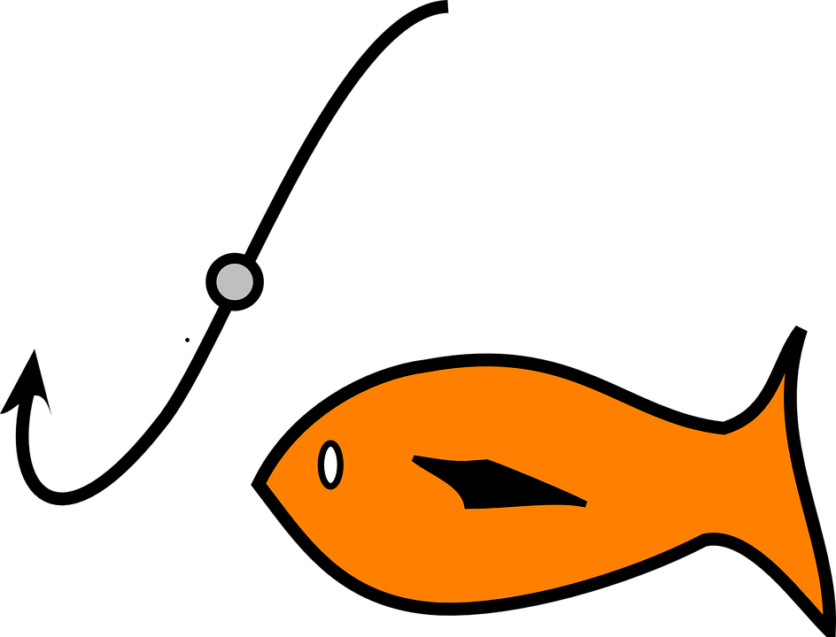
To Do
(Comfort)
To Be
(Control)
To Have
(Covet)
Satan’s Bait
Lust of the Flesh
Lust of the Eyes
Pride of Life

IV. Lust of the flesh: To Do (COMFORT)

A. Temptation to do anything you want to do (no limits)

1. Satan asked her in Gen. 3:1b Did God actually say, ‘you shall not eat of any tree in the garden’? (ESV)

2. Desire to satisfy a physical craving in the wrong way

3. Consuming desire to experience pleasure

Genesis 3:6a So when the woman saw that the tree was good for food… (ESV)

B. Accusation against God’s GOODNESS

1. God’s goodness and love are challenged in this temptation.

2. God is holding back His best for you. His provision is not as good as it could be: “I feel ……… (i.e. tired, lonely, sad) so I am going to satisfy my physical desire no matter what God says.”

C. Satan in Matthew 4:3

And the tempter came and said to him, ’If you are the Son of God, command these stones to become loaves of bread.’ (ESV)

D. Jesus in Matthew 4:4

It is written, ‘Man shall not live by bread alone but by every word that comes from the mouth of God.’ (ESV)

E. The only answer is to read and obey the Word of God over and above one’s own feelings. God’s Word is the antidote.

V. Lust of the eyes: To Have (COVETOUSNESS)

A. Temptation to have anything you desire to POSSESS without limits

1. Satan exclaimed to her in Gen. 3:4 ‘…you will not surely die.’ (ESV)

2. Desire to possess something God has not given yet

3. Compelled to Possess what is visible despite consequences

4. Living by what is seen rather than living by faith

5. Idolatry at the core; living for self

6. Gen. 3:6b that it was a delight to the eyes… (ESV)

B. Accusation against God’s WISDOM

1. God’s wisdom and omniscience is challenged...

2. “I see it, I want it, I’ve got to have it no matter what…”

C. Satan in Luke 4:5-7 And the devil took him up and showed him all the kingdoms of the world in a moment in time, and said to him, “To you I will give all this authority and their glory, for it has been delivered to me, and I give it to whom I will. If you, then, will worship me, it will be yours.” (ESV)

D. Jesus in Luke 4:8 And Jesus answered him, “It is written, “You shall worship the Lord your God, and him only shall you serve.” (ESV)

E. The only answer is to serve God and worship Him alone

1. Must trust in Him and His wisdom rather than in oneself
(Prov. 3:5-8)

2. WORSHIP of God is the antidote.

VI. Pride of Life: To Be (LOVE OF CONTROL)

A. Temptation to be anything you want to BE

1. Satan encouraged Eve in Genesis 3:5 to be like God

Genesis 3:5 For God knows that when you eat of it your eyes will be opened, and you will be like God, knowing good and evil. (ESV)

2. Desire to receive praise and attention of others

3. Desire to be in control

4. Competitiveness to Achieve; Trusting self’s power

5. Genesis 3:6c that the tree was to be desired to make one wise (ESV)

B. Accusation against God’s SOVEREIGNTY

1. God’s sovereignty or omnipotence (power) is challenged…

2. …by presuming upon God for personal recognition

3. “I can do this myself,” or “My will be done,” or “God will rescue me and fix it if it does not work out.”

C. Satan to Jesus in Luke 4:9-11 And he took him to Jerusalem and set him on the pinnacle of the temple and said to him, “If you are the Son of God, throw yourself down from here, for it is written, “‘He will command his angels concerning you, to guard you,’ and “‘On their hands they will bear you up, lest you strike your foot against a stone.’” (ESV)

D. Jesus to Satan in Luke 4:12 And Jesus answered him, “It is said, ‘You shall not put the Lord your God to the test.’” (ESV)

1. Doing the WILL of GOD rather than one’s own will

2. Say to yourself what Jesus said to the Father in

Luke 22:42 Not My will but Your will be done. (ESV)

E. Only answer is Submission

1. Humility required

2. Doing the WILL of GOD is the antidote

VII. “Addiction” Manifestations

A. Gambling (I Tim. 6:10; 2 Tim. 3:2)

Lust of the Flesh – “Going to the casino is fun & exciting!”

Lust of the Eyes – “I want the money, and I already know how I am going to spend it!”

Pride of Life – “I can figure this out on my own and beat the system.”

Statement combining all three in one: “This is so fun; I can’t wait to win all of that money because my friends will see that I am rich and successful!”

B. Drugs and Alcohol

Lust of Flesh – “I love partying with my friends,” or anticipation before getting the drug, “This is going to be so much fun. I can’t wait.”

Lust of Eyes – “I have got to have a drink just to feel like I see normal people: relaxed.”

Pride of Life – “I can control this addiction because I become who I want to be.”

Statement combining all three in one: “I love the way this makes me feel because I become relaxed and more like who I want to be.”

C. Stages of Addiction

At first, the lust of the flesh stage is fun when one is simply experimenting with the sin of choice.

Then, the lust of the eyes says at heart, “I’ve got to have this!”

Finally, the pride of life desires the sin of choice because it becomes part of who they are; identity. This is the third and final stage.

VIII. Empowered by Christ
- All temptations have been defeated by Jesus.
Heb. 2:17-18 Therefore he had to be made like his brothers in every respect, so that he might become a merciful and faithful high priest in the service of God, to make propitiation for the sins of the people. For because he himself has suffered when tempted, he is able to help those who are being tempted.
Heb. 4:14-16 Since then we have a great high priest who has passed through the heavens, Jesus, the Son of God, let us hold fast our confession. For we do not have a high priest who is unable to sympathize with our weaknesses, but one who in every respect has been tempted as we are, yet without sin. Let us then with confidence draw near to the throne of grace, that we may receive mercy and find grace to help in time of need.

The Holy Spirit inside of a Christian gives the power to will and to do what God requires. (Phil. 2:12-13)

Identify the preference to sin in your counselee … after you have identified them in your own heart, that is.

Then, emphasize the three specific solutions for that specific temptation: WORD, WORSHIP, and WILL of GOD

Word: instead of my own comfort; ultimate source of Comfort is the Holy Spirit understanding of the Word of God

Worship: instead of desires of my flesh; ultimate satisfaction found in the worship of the One true God not in the temporal things of this life (Col. 3:2)

Will of God: instead of my will; my hope is not in what I can control; it’s in the One who is in control

Ultimately, the goal is to become more like Christ for God’s glory. I John 2:15-17 Do not love the world nor the things in the world. If anyone loves the world, the love of the Father is not in him. For all that is in the world, the lust of the flesh and the lust of the eyes and the boastful pride of life, is not from the Father, but is from the world. The world is passing away, and also its lusts; but the one who does the will of God lives forever.

Portions of this presentation are excerpted from the booklet by Dr. Mark E. Shaw entitled, Understanding Temptation: The War Within Your Heart, available from Focus Publishing (Bemidji, MN) in the USA. For international shipping, contact Christian Book Distributors.

